



[](https://www.bing.com/images/search?q=science+clipart&id=B4E71B5731D40C9941F532831E9CA14968E596F9&FORM=IQFRBA)**Science Fair Information**[](https://www.bing.com/images/search?q=science+clipart&id=B4E71B5731D40C9941F532831E9CA14968E596F9&FORM=IQFRBA)

Dear parents/guardians,

All Richmond County fourth-fifth graders are required to submit a Science Fair Project. Copeland’s Science Fair will be held on February 16th 2022. **Projects will not be accepted for judging after the morning of Feb. 10th.**

Your child will need a composition journal to be used as a log book, a 3-prong folder or clear folder for the typed formal report. Your child will be completing their Science Project virtually using a PowerPoint template. No physical display board will be required. Your child will submit a log book, typed formal report and the PowerPoint presentation in place of the backboard. Parents, you can access this template on the Copeland website under the Science Fair Project tab. Your child’s teacher will also upload the template on their Canvas Page.

The following packet of information attached to this letter is provided to assist you in helping your child with their Science Fair project. Inside you will find information on selecting a topic, research questions, how to do research, forming hypotheses, and directions on testing those hypotheses. You will see information on how to collect data and the proper way to set up the presentation. I have also included a page with websites of science project ideas that I hope is helpful in getting you started.

Please be sure that your project is an experiment and not a model (no volcanoes, etc) and there should be no photos showing any body part including hands on your display board. Take pictures of the actual experiment **only**. **Per Richmond County, please do not do any experiments on vertebrate animals or humans (this includes taste tests) or anything having to do with growing mold.**

All information gathered should be typed in the log book template on the PowerPoint provided. This is where their teacher will look for all assignments from the checkpoints listed inside this packet. You can also access this packet on the Copeland Website under the Science Fair Project tab.

I have also attached list of due dates. On those dates your student’s teacher will check your child’s work on only the assignments listed for that particular date. Each due date will count as a grade, and then will be averaged to count as a quiz grade. The final completed project will count as **two test grades in Science**, so be sure all the needed components are there.

Please make sure that your little scientist is turning in their information by the required due dates listed below! Please allow your child to assume as much responsibility as possible for the project. They will need your assistance, but we do not want you to do it for them. For example, when your child writes the report to accompany the project, you should proofread the written report, make suggestions, and offer assistance in typing the report.

If you have any questions, do not hesitate to call.

Ms. Perry

Science Fair Coordinator

Mrs. Prescott

Science Teacher in Residence

[](https://www.bing.com/images/search?q=science+clipart&id=B4E71B5731D40C9941F532831E9CA14968E596F9&FORM=IQFRBA)**Science Fair Due Date Checklist**[](https://www.bing.com/images/search?q=science+clipart&id=B4E71B5731D40C9941F532831E9CA14968E596F9&FORM=IQFRBA)

**Scientist’s Name_____________________Class___________Proj. #_______**

**Title of Project____________________________________________**

|  |  |  |  |  |
| --- | --- | --- | --- | --- |
| Due Date | Assignment | Correct | Needs Improvement | Areas in need of improvement |
| **November 2, 2021 all Science Fair packets sent home with 4th and 5th graders for parents to review with their students.** | | | | |
| Nov. 9, | Title and Purpose |  |  |  |
| Nov. 30, | Research and Bibliography |  |  |  |
| Dec. 14, | Hypothesis, Variables, Materials, Procedure |  |  |  |
| Jan 11, | Data, Analysis, Conclusion, Extension Statement |  |  |  |
| Jan. 18, | Abstract and Formal Reports |  |  |  |
| Jan. 25, | Final PowerPoint Presentation |  |  |  |
| Feb 1, | Any revisions |  |  |  |

**Total Score (average of all due dates): __________**

100 - Turned in on time ☺

80 - Not turned in by due date, but is in composition journal for the next due date

75 - Turned in, but is very late

0 - Never Completed ☹

Schedule of Assignments

Tuesday, Nov 2. Science Fair packets go home

Tuesday, Nov 9. Assignment #1 is due for approval: Title and Purpose (Testable Question)

Tuesday, Nov 30. Assignment #2 is due: Research and Bibliography

Tuesday, Dec 14 Assignment #3 is due: Hypothesis, Variables, Materials, and Procedure

Tuesday, Jan 11 Assignment #4 is due: Data, Analysis, Conclusion, and Extension Statement

Tuesday, Jan. 18 Assignment #5 is due: Abstract and Formal Report

Tuesday, Jan 25 Assignment #6 is due: Final PowerPoint Presentation

Tuesday. Feb 1 Assignment #7 is due: Any revisions must be complete

Tuesday, Feb 15 Projects will be set up for the Fair

Wednesday, Feb 16 Virtual Science Fair Judging

Science Project Ideas

The following websites are extremely helpful in finding Science Fair project ideas.

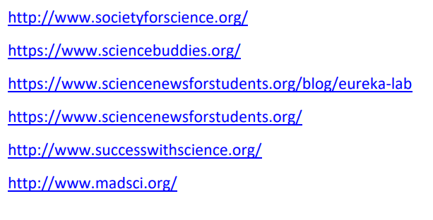

This is the best site to use:

<http://www.sciencebuddies.org>

[](https://www.bing.com/images/search?q=science+clipart&id=B4E71B5731D40C9941F532831E9CA14968E596F9&FORM=IQFRBA)**Teacher Checklist for Science Fair Entry**[](https://www.bing.com/images/search?q=science+clipart&id=B4E71B5731D40C9941F532831E9CA14968E596F9&FORM=IQFRBA)

Teachers,

Please use this checklist for each project you plan to enter in the school Science Fair. This will save us a ton of time when we are setting up the projects. Please turn these sheets in to me when you submit the projects. Projects that do not have all the necessary parts by the morning of **Feb. 2nd 2022** will not be accepted. You should only enter the best of the best. Students must submit a log book, typed formal report and their PowerPoint in place of the backboard. Please make parents aware of this, and let them know that you will display the projects that do not make it into the Fair in the hall on your website.

**Student Name ________________________ Class___________ Proj. #_____**

**Title of Project** _________________________________________________

Please make sure project has the following:

**No** name on **any** part of project (log book, typed formal report and PowerPoint) _______

Complete Log Book ________

Complete Formal Report _________

Abstract (Presented in the PowerPoint) ________

PowerPoint labeled with their last name, first initial and grade level. (ex: Jones.S.4) _______

Pictures on PowerPoint **DO NOT** show any body parts including hands ______

PowerPoint is neat, pleasing to the eye, and well put together _______ (no transitions, animations, music or distracting graphics)

Project is an experiment and **NOT** a model (example: volcano, solar system) ______

**\*The only three things that will be submitted will be the PowerPoint Presentation, the log book and the typed formal report. \***

**1. Purpose – Ask a Testable Question**

**A Testable Question has 2 Part:**

**Part 1:**  The part that is being tested. It is called the independent variable. This is the manipulated variable or the one that changes.

**Part 2:** The part that is being observed or measured. It is the dependent variable, or the responding (measured) variable.

The question describes the relationship between the two parts:

***How does the (independent variable) affect the (dependent variable)?***

**Example: How does the temperature affect the rate of seed germination?**

***What is the effect of the independent variable on the dependent variable?***

**Example: What is the effect of temperature on the rate of seed germination?**

**You MUST be able to measure your dependent variable.**

**2. Conduct Your Research and Create a Bibliography**

**\*This information DOES NOT go on your display board.**

**Once you have chosen your topic, it is important to research the written materials on your subject. By finding out as much information about the subject, you will gain a better understanding of your problem. *Follow these guidelines for conducting your research.**

1. Read books and articles on your subject. Make sure this information is up to date (not older than 5 – 10 years).

2. You must use at least 3 resources. Cite your work above your notes.

3. In your log book, you will include only your notes from your sources. Use will use these notes to write the research paper in your formal report after you complete the entire experiment.

***Bibliography***

**Make a list of all the books, magazines, internet articles, interviews, or other sources that were used. *Write your bibliography using the following format:**

**Books:**

Author’s last name, first name. *Book title.* City of publication: Publishing Company, publication date.

**Example:**

Allen, Thomas B. *Vanishing Wildlife of North America.* Washington, D.C.: National

Geographic Society, 1974.

**Internet:**

Author’s last name, first name (if available). “Title of work within a project or database.” *Title of site, project, or database.* Editor (if available). Electronic publication information (Date of publication or of the latest update and name of any sponsoring institution or organization).

Date of access and <full URL>.

Note: If you can’t find some of this information, cite what you can.

**Example:**

Devitt, Terry. “Lightning injures four at music festival.” *The Why? Files.* 2 Aug. 2001. 23 Jan. 2002.

<http://whyfiles.org/137/lightning/index.html>

**Encyclopedia and Dictionary**

Author’s last name, first name. “Title of Article.” *Title of Encyclopedia.* Date.

**Examples:**

Pettingill, Olin Sewall, Jr. “Falcon and Falconry.” World Book Encyclopedia. 1980.

“Azimuthal Equidistant Projection.” Merriam-Webster’s Collegiate Dictionary. 10th ed. 1993.

**\*See your teacher for help if you use any other type of source.**

[](https://www.bing.com/images/search?q=science+clipart&id=B4E71B5731D40C9941F532831E9CA14968E596F9&FORM=IQFRBA)**3. Construct a Hypothesis**[](https://www.bing.com/images/search?q=science+clipart&id=B4E71B5731D40C9941F532831E9CA14968E596F9&FORM=IQFRBA)

**A Hypothesis includes a prediction about you believe, based on your research, will happen when your investigation is completed.**

**Follow these steps to complete a hypothesis:**

* **List observations or gained research knowledge you have about the variables.**
* **Write an *if…..then* statement describing what the effect of changing one variable on another variable. (This is a cause/effect relationship).**

**Example:**

**If (what will be changed with the independent variable), then (what will happen because of the change – dependent variable) because (use your observations or gained research knowledge to explain your belief).**

*If seeds are exposed to freezing temperatures for a short period of time, then the germination rate will increase because research indicates that certain seeds will germinate more quickly if they are put in a freezer before planting.*

[](https://www.bing.com/images/search?q=science+clipart&id=B4E71B5731D40C9941F532831E9CA14968E596F9&FORM=IQFRBA)**Identify the Variables**[](https://www.bing.com/images/search?q=science+clipart&id=B4E71B5731D40C9941F532831E9CA14968E596F9&FORM=IQFRBA)

**Create a list of each type of variable. Remember, the independent variable is the one that changes. The dependent variable is the response you are looking to get. The control variable is the one that remains the same.**

**Example:**

Control Variable: number of beans per bag, time stored, amount of water and sunlight while germinating  
  
Independent Variable: temperature of storage  
  
Dependent Variable: number of seeds germinating

[](https://www.bing.com/images/search?q=science+clipart&id=B4E71B5731D40C9941F532831E9CA14968E596F9&FORM=IQFRBA)**Materials** [](https://www.bing.com/images/search?q=science+clipart&id=B4E71B5731D40C9941F532831E9CA14968E596F9&FORM=IQFRBA)

**Make a list of all materials that you use.**

**Example:**

16.7cm x 15.1cm Zip-Loc bags

60 uncooked butterbeans  
(3) 27.9cm x 26.4cm paper towels  
Permanent Marker  
De-chlorinated tap water  
Approximately 70 degrees Fahrenheit room  
Approximately 38 degrees Fahrenheit refrigerator  
Approximately 0 degrees Fahrenheit

[](https://www.bing.com/images/search?q=science+clipart&id=B4E71B5731D40C9941F532831E9CA14968E596F9&FORM=IQFRBA)**Procedure** [](https://www.bing.com/images/search?q=science+clipart&id=B4E71B5731D40C9941F532831E9CA14968E596F9&FORM=IQFRBA)

**Write a set of directions for completing your experiment. Remember to write complete sentences and use punctuation.**

**Example:**

1. Label the plastic bags as follows: Room temperature (control) bean, 50 degree F. (refrigerator) bean, 30 degree F. (freezer) bean.

2. Fold paper towels to fit in bags. Place in bags.  
  
3. Place 20 beans in each bag.

4. Put each bag in proper place as said on bag label.  
  
5. Leave undisturbed for 5 days.  
  
6. After the 5 days remove the bags. Wet the paper towel with 15mL of dechlorinated tap water but leave the towel and seeds in bag. Towel should be moist but not soaking.  
  
7. Place bags in warm, sunny spot.  
  
8. Check every day for 10 days for germination. Keep towels moist.  
  
9. Record your findings. Repeat as necessary.

[](https://www.bing.com/images/search?q=science+clipart&id=B4E71B5731D40C9941F532831E9CA14968E596F9&FORM=IQFRBA)**4. Collect Data** [](https://www.bing.com/images/search?q=science+clipart&id=B4E71B5731D40C9941F532831E9CA14968E596F9&FORM=IQFRBA)

**You will need to construct a table to collect your data. A table contains rows and columns.**

* Give your data table a title. The title should contain your independent variable (the one that changes) and the dependent variable (the responding) and be at the top of your table. **For example: *Germination Rate of Butterbean Seeds vs. Temperature***
* Make a row for each independent variable you are testing.
* Make a column for each dependent variable you are measuring.
* Include unit names for each measurement.
* Add an “Average” column or a “Total” column if applicable.

**Example:**

***Germination Rate of Butterbean Seeds vs. Temperature***

|  |  |  |  |
| --- | --- | --- | --- |
| **Days** | **Control – Room Temperature** | **Freezer** | **Refrigerator** |
| **1** | 0 | 0 | 0 |
| **2** | 2 | 0 | 1 |
| **3** | 6 | 2 | 4 |
| **4** |  |  |  |
| **5** |  |  |  |
| **6** |  |  |  |
| **7** |  |  |  |
| **8** |  |  |  |
| **9** |  |  |  |
| **10** |  |  |  |

**\*Keep recording daily for ten days.**

[](https://www.bing.com/images/search?q=science+clipart&id=B4E71B5731D40C9941F532831E9CA14968E596F9&FORM=IQFRBA)**Analysis** [](https://www.bing.com/images/search?q=science+clipart&id=B4E71B5731D40C9941F532831E9CA14968E596F9&FORM=IQFRBA)

**Create a graph of your recorded information. You may use a bar graph or a line graph. If you are showing information that happens over a period of time, a line graph is preferred.**

**Example:**

**You would need to conduct at least three trials. If after the three trials, you have the same results, then you can draw a conclusion.**

[](https://www.bing.com/images/search?q=science+clipart&id=B4E71B5731D40C9941F532831E9CA14968E596F9&FORM=IQFRBA)**Conclusion** [](https://www.bing.com/images/search?q=science+clipart&id=B4E71B5731D40C9941F532831E9CA14968E596F9&FORM=IQFRBA)

**A Scientific Conclusion has these parts in order:**

* **State the prediction.**
* **Include evidence from your data collection. Do not include all your data. Include a high and low, if possible – include averages, or appropriate central measures.**
* **Include a statement that analyzes the data.**
* **Include a statement that tells if the prediction was correct or incorrect. Use the sentence starter: Therefore my prediction was….(correct or incorrect).**

**Example:**

The results of my experiment show that my hypothesis was incorrect. The seeds in the freezer germinated the fewest, while the ones at room temperature germinated the largest amount of seeds.

[](https://www.bing.com/images/search?q=science+clipart&id=B4E71B5731D40C9941F532831E9CA14968E596F9&FORM=IQFRBA)**Extension Statement**[](https://www.bing.com/images/search?q=science+clipart&id=B4E71B5731D40C9941F532831E9CA14968E596F9&FORM=IQFRBA)

**In this section, you will tell what you would do differently next time to see if you get the same results.**

**Example:**

I believe that further testing needs to be done to see which temperature induces the highest germination rate. If I was to perform this experiment again, I would use a different type of bean to see if my results would be the same.

[](https://www.bing.com/images/search?q=science+clipart&id=B4E71B5731D40C9941F532831E9CA14968E596F9&FORM=IQFRBA)**Abstract**[](https://www.bing.com/images/search?q=science+clipart&id=B4E71B5731D40C9941F532831E9CA14968E596F9&FORM=IQFRBA)

**The Abstract is a summary of the entire project. It should be typed in three paragraphs using the same font and type size as your Formal Report. You do not have to write the Abstract in your notebook. It should be no more than 250 words. Please make sure to do a word count to make sure that you do not go over this number.**

**Paragraph #1: Purpose of the experiment and the Hypothesis**

**Paragraph #2: Procedure written in paragraph form**

**Paragraph #3: Results and Conclusion**

**Example:**

The purpose of this project is to determine if temperature will affect the germination rate of butterbean seeds. It is hypothesized that freezing the seeds for a period of time will cause them to produce more seeds at a quicker rate.

A set number of butterbean seeds were placed in plastic bags marked “room temperature”, “freezer”, and “refrigerator”. The bags were placed in the respective areas and left undisturbed for five days. They were all then moistened and placed in a warm, sunny area where they were observed for ten days.

The results showed that the coldest temperature actually harmed the germination rate of the seeds; therefore, my hypothesis was incorrect. To improve this study, I would try different types of seeds to see if my results could be confirmed.

[](https://www.bing.com/images/search?q=science+clipart&id=B4E71B5731D40C9941F532831E9CA14968E596F9&FORM=IQFRBA)**PowerPoint Presentation**[](https://www.bing.com/images/search?q=science+clipart&id=B4E71B5731D40C9941F532831E9CA14968E596F9&FORM=IQFRBA)

**Do and Don’ts:**

* No flash and fancy transitions, animations or music
* Photos and graphics - must be by student and have credits
* Do not alter the template
* You may use up to two additional slides for presenting photos of the procedure and charts and graphs (no body parts, including hands may be shown)
* Do use a catchy title. It should **NOT** be the question that is your purpose statement.
* Don’t make spelling errors.

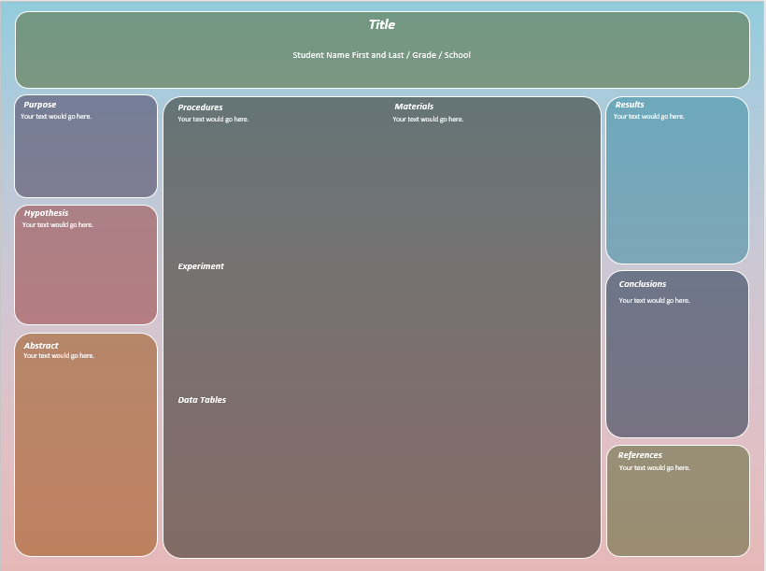

**You should have the following on your board only: Title, Purpose (this is your question), Hypothesis, Materials, Abstract, Procedure, Results, Conclusion, and any photographs, charts, and graphs.**